Autonomous Tweeting: An Application of IoT

**Abstract**

The concept of Internet Of Things has been around for almost a decade now. It has successfully amalgamated sensors and actuators into the environment around us, which enables its users to develop a common operating point (COP) and provide cross-platform sharing of data. The IoT has moved onto its next revolutionary phase of changing the present format of Internet into a fully integrated one due to the emergence of various wireless technologies such as embedded sensors and RFID tags. One such adaption is achieved here using an Arduino to upload data wirelessly using the interweb and live tweet it using the users twitter account. This allows data to accessed from anywhere over the globe by anyone which leads into the development over data analytics.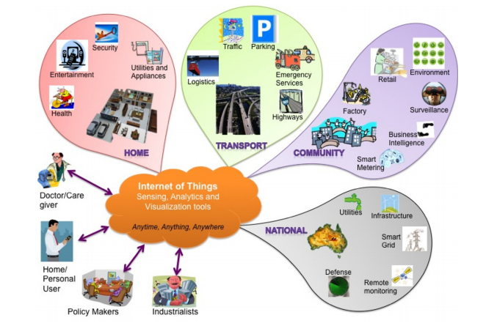

**Introduction**

The way in which personal information is being retrieved and stored has brought a major change in thinking of developers vis-à-vis anyone and everyone can access the data remotely because using the data through a physical device has gone out-of-date. This change in the way things work is brought about due to the evolution in the thinking of the current generation.

That’s how cloud computing has emerged and widespread to meet the demand of current Industrial requirements. The data to be worked upon is collected directly from the sensors and devices and uploaded to the cloud which serves as a portable data center for modern tools of data analytics. This Zettabytes of raw data has to be worked upon to obtain substantial information[1].

Implementation of these concepts requires the use of various sensors (module/interface) which integrate with the Arduino board to achieve the project conceptualization. Here we use the Arduino Uno board which is interfaced with the ESP8266 Wi-Fi module for long fidelity connection or the Bluetooth HC-05 module for shorter fidelity and the DHT11 sensor for sensing the temperature and humidity of the surrounding air. This data which is gathered by the Arduino is pushed to the ThingTweet server via the HTTP POST request which can be done using the API (Application Program Interface) which is provided by the ThingTweet application. This API can be in turn be used to tweet the temperature and humidity values through the user’s twitter account. This is where Cloud Computing comes into picture.

**Sensors**

**DHT11- The Humidity Sensor**

This particular **humidity sensor** is calibrated to sense, measure as well as report the percentage of moisture content in the air. DHT11 detects the relative humidity of its contiguous surrounding. It represents the ratio of moisture in the air to that of the highest value that could have been held in the air at the current temperature by detecting the moisture content, and is expressed as a percentage. These sensors such as the DHT11 work on the basic principle of capacitive measurement i.e. it depends on the electrical field that will be created by a non-conductive polymer film that lies between two electrical conductors. There is a change in the potential between the layers as the moisture content present in the air gets collected over this film. Thus, while taking the current temperature of the air into account, the spike in the potential difference is converted into a format so as to work upon the obtained data easily i.e. the digital format.

**ESP8266-Wifi Module**

The ESP8266 is a low-cost Wireless Fidelity (Wi-Fi) chipset with full Transfer Control Protocol (TCP)/Internet Protocol (IP) stack and Microcontroller unit (MCU) capability. The basic TCP/IP connections using Hayes-style commands are achieved through this ESP8266-12 Wi-Fi module.

The architecture of ESP8285 is basically the same as that of its predecessor ESP8266 with 1MB of built-in flash memory allowing it to connect to Wi-Fi as an individual chip device[5].

**HC05-Bluetooth Module**

This HC-05 module is a Bluetooth Serial Port Protocol (SPP) module which is designed for transparent wireless serial connection setup. Wireless Communication can be obtained effortlessly by using this HC05 Bluetooth module as it can be configured to be used in a Master or Slave format. This module also uses the adaptive frequency hopping feature which results in an enhanced range. Establishing a connection to various other devices can be initiated only by the Master of that particular network, whereas the Slave can only accept connections[6].

**Arduino**

Arduino is a free to use, development hardware and software project, and a huge group that has designed a Single-board microcontroller kits that can be used in varieties of electronics project. Interfacing of various circuits can be obtained with the help of input/output (I/O) pins which are either digital or analog. Certain programs can be uploaded into the microcontrollers via UART Serial Communications or USB interfaces. The process of programming or uploading the programs into the microcontroller is basically built on C & C++ which in turn provides us with an Integrated Development Environment (IDE) for us to work in a comparatively easier way. [4].

**Types of Arduino**

|  |  |  |  |  |
| --- | --- | --- | --- | --- |
| **Arduino Board** | **Processor** | **Memory** | **Digital I/O** | **Analogue I/O** |
| Arduino Uno | 16Mhz ATmega328 | 2KB SRAM, 32KB flash | 14 | 6 input, 0 output |
| Arduino Due | 84MHz T91SAM3X8E | 96KB SRAM, 512KB flash | 54 | 12 input, 2 output |
| Arduino Mega | 16MHz ATmega2560 | 8KB SRAM, 256KB flash | 54 | 16 input, 0 output |
| Arduino Leonardo | 16MHz ATmega32u4 | 2.5KB SRAM, 32KB flash | 20 | 12 input, 0 output |

**Cloud Computing**



Cloud computing is an Internet-based computing system which provides shared computing resources and data to as a service to various other devices on demand. Cloud computing provides users and enterprises a solution to store and process the data stored in different data centers located in remote places. Cloud computing is based on pay as you occupy model hence resulting in economy of scale. [3]

**Advantages of using Cloud Computing**

**Disaster Recovery**: Cloud Computing provides robust backup and recovery solutions that are hosted in cloud. Due to this there is no need to spend extra resources on homegrown disaster recovery. It also saves time in setting up disaster recovery.

**Low Capital Expenditure**: There is very less upfront capital expenditure and there is a variable payment that is based on the usage.

**Collaboration:**In a cloud environment, applications can be shared between teams. This increases collaboration and communication among team members.

**Remote Work:** Cloud solutions provide flexibility of working remotely. There is no on site work. One can just connect from anywhere and start working.

**Security:**Cloud computing solutions are more secure than regular onsite work. Data stored in local servers and computers is prone to security attacks. Cloud providers give a secure working environment to its users.

**Disadvantages of Cloud Computing**

**Security Concerns:**One of the major disadvantages pertaining to cloud computing is that the data is stored in the cloud provided by the third party. This raises some trust issues as the data also contains crucial information about the company.

**Downtime Issues:**The providers of the cloud services have to handle many customers every day, which gives them the ultimate power to cut down their services to the customers.

**Bandwidth Issues:**To obtain the smooth functioning, the customers are required to organize and not clutter the servers.

**Role of cloud in IoT**

Internet of Things has put a lot of demand on infrastructure-mainly around stability, connectivity and processing power. Cloud computing can be implemented to overcome this challenge as it acts as a backbone by providing easier accessibility.

Why the Cloud is considered as a backbone to IoT[2]?

**1.     Remote processing power**

IoT is growing at a rapid rate and soon, all devices will be connected to the internet.

This increase in devices will put a new demand on the processing power. The Cloud will allow users to let the cloud handle the computing services.

**2.      Accessibility**

Due to the implementation of cloud in IoT, many developers can enter into the field without the backing of a large corporation. The cloud makes it easier for developers to enter the IoT field. The users can avail the features offered by the cloud such as a predefined infrastructure.

**3.      Analytics**

The cloud offers various tools that enable the developer to analyze and visualize the data.

**4.      Security concerns**

The main disadvantage pertaining to IoT is the effect it has on security and privacy. Many obsolete devices are vulnerable to security exploits. Despite this major concern, the cloud could sidestep this security issue. Crucial security patches are updated on every device instantly.

**Integrating Arduino to Talk to Twitter via Internet**

The ThingTweet application is used to link a user’s Twitter® account to the user’s ThingSpeak™ account. Devices and channels can update via Twitter using the TweetControl API which is obtained from the ThingSpeak™.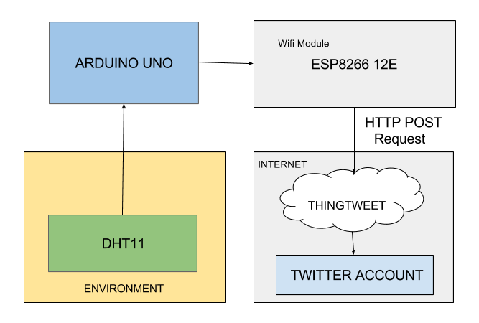

The Arduino Uno Board gets the temperature and moisture values of the environment from the DHT11 sensor which is connected to one of the ports on the Board.

Once the valid values are read, the Arduino Uno sends it to the ESP8266 Wifi Module via serial transmission protocol.

ESP8266 is calibrated to work on station mode. The module is connected to a stable internet connection for a seamless flow of data from the DHT11 sensor to the internet. The ESP8266 generates a HTTP POST request towards the ThingTweet Server using its API and values are sent as a status to particular twitter account.

**Conclusion**

It is quite apparent that the concept of The Internet of Things (IoT) has made an enormous impact on the current world of Science and Technology. Designing innovative applications in the field of automation systems demands the at most creativity of the user. This domain of IoT is being influenced by the high paced changing data and the required computational resources for creating ground breaking applications pertaining to it. Here is a model which uses a cloud approach to attain this goal which revolves around the user, through the interaction with the Arduino board and the sensors which seamlessly blend to provide a method of remote data collection, which can provide a revolutionary visualization of the vast amounts of data which is generated from all the devices that are connected to the internet, that can be utilized in the emerging field of Data Analytics and Data Sciences.

**References**

1. Internet of Things (IoT): A vision, architectural elements, and future . Authored by: Jayavardhana Gubbi, Rajkumar Buyya, Slaven Marusic, Marimuthu Palaniswami
2. https://www.knowlarity.com/blog/the-role-of-cloud-tech-in-the-internet-of-things/
3. <https://en.wikipedia.org/wiki/Cloud_computing>
4. https://en.m.wikipedia.org/wiki/Arduino
5. https://googleweblight.com/i?u=https://wiki.eprolabs.com/index.php?title%3DWiFi_Module_-_ESP8266&grqid=nEI-7z73&hl=en-IN
6. <http://wiki.jmoon.co/sensors/hc-05-bluetooth/>
7. community.thingspeak.com

**About the Authors**

Mr. Ali Asger Mustafa Tabha [CSI: 01391290] is studying in II year of B.E. (CSE) at JSS Academy of Technical Education, Bangalore (Karnataka). His areas of interest include Robotics, Data Statistics, Data Analysis and Data Sciences. He can be reached at [ali.tabha@yahoo.com](mailto:ali.tabha@yahoo.com).

Mr. Arjun H M [CSI: 01391295] is studying in II year of B.E. (CSE) at JSS Academy of Technical Education, Bangalore (Karnataka). His areas of interest are Python, MySQL, Machine Learning and Databases. He can be reached at [arjunsuarez@gmail.com](mailto:arjunsuarez@gmail.com).

Mr. Arvind R [CSI: 01391297] is studying in II year of B.E. (CSE) at JSS Academy of Technical Education, Bangalore (Karnataka). His areas of interest are App development, cyber security programming and cloud computing. He can be reached at [arvindraman23@gmail.com](mailto:arvindraman23@gmail.com).

Mr. Ashwani Arya [CSI: 01391298] is studying in II year of B.E. (CSE) at JSS Academy of Technical Education, Bangalore (Karnataka). His areas of interest are App development, Computer Graphics, Game Development and Artificial Intelligence. He can be reached at [ashwaniparker@gmail.com](mailto:ashwaniparker@gmail.com).

Dr. Sneha Y.S (F8001135) is working as Associate Professor in Department of Computer Science and Engineering at JSS Academy of Technical Education, Bangalore(Karnataka).  Her areas of interest are Web Mining and Big Data Analytics. She can be reached at [sneha.girisha@gmail.com](mailto:sneha.girisha@gmail.com)